United States Contract Weather Observing Association
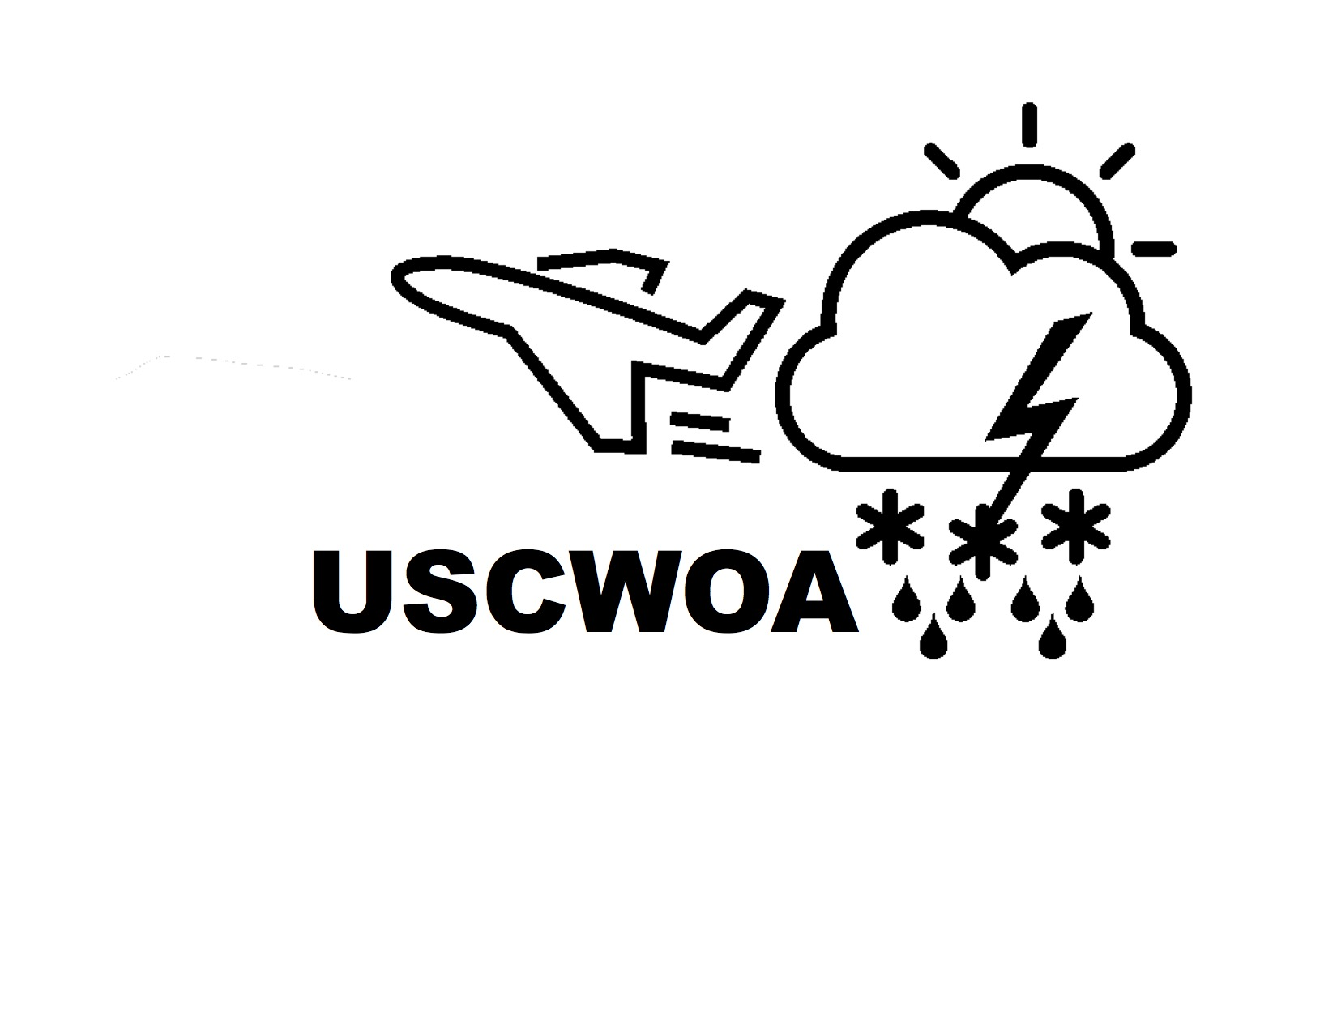
616 Lakemont Drive USCWOA@outlook.com
Dalton, GA 30720 501 (c) (6) Non-Profit
Established 2017
Proudly Serving the FAA CWO Program and the Aviation Community

United States Contract Weather Observing Association
Dues Deduction Authorization Form

NAME:

STATION/STATIONS (Rover)

TO (employer):

I hereby request and authorize you to deduct from my earnings each payroll period, an amount sufficient to provide for regular payment of the current rate of monthly USCWOA dues per hour worked as established by the USCWOA Board. The amount shall be in accordance with the provisions of the By-Laws of the USCWOA. That amount shall be $0.20 per hour worked.

SIGNATURE:

EMAIL: ________________________________________

ADDRESS:

___________________________________________

DATE:

